# topic proposal document

The purpose of flatfood is for flaters to share meal ideas and recipes;

I want my website to be easily na vigated on any device to find submit and review recipes with ease.

This website is targeted at flaters so people between the ages of 18-26.

The website is addressing the lack of simple and cheap meals

The type of content on my website will be recipes with pictures of the recipes along with reviews of recipes and dishes of the week/month in a newsletter that's emailed every month.

Foodinaminute is similar to my proposed website but is owned by watties and in turn is bound to their products.

<http://www.bite.co.nz/> is also similar more so than foodinaminute because user submitted recipes.

# Planning Analysis

1

The goal of this website is to connect flatters with food creations and a way to comment how to make each others meals better.

2

The information i need will be sourced from github cookbooks protected under gpl so use of the information is legal

3

My project will use forms for getting users emails to sign them up for a monthly mailer

4



5

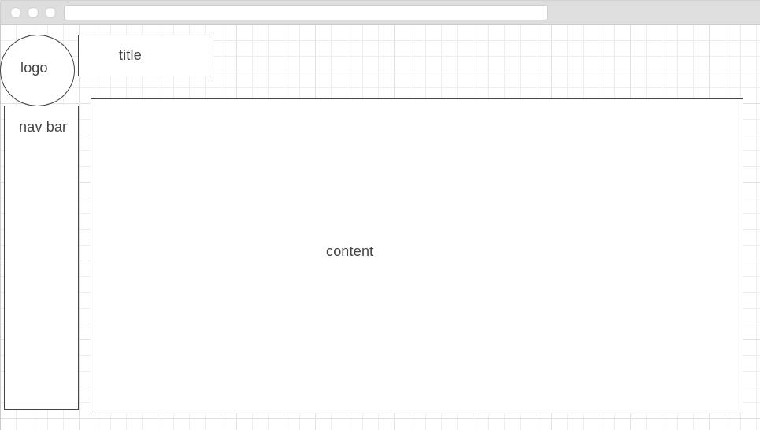

# Report

The website i am created is for flatters to find and share meal ideas and recipes. So that when it comes time to decide what to cook its not that big of a deal you just load up the website and browse till you find something you like. This website will be similar to foodinaminute and bite but will have a larger emphasis on sharing recipes rather than being served recipes from watties(foodinaminute) or other users(bite).

I believe the site is functional but integrating automatic page generation from user inputted recipes and a search function would allow for the user experience to be alot better and getting content on the site to be alot easier this would also mean that the newest page will have to dynamically update as new pages are added. Categories would also be a good addition as the current setup only allows for one category this would allow the ability to filter out meal type like dinner lunch and snacks. It would also be good to add a comment section and a rating section also maybe a fork option for when people change or add to recipes.

Link to website: <https://seat-webdev.massey.ac.nz/16453897/158258/ass3/index.html>

# Appendix

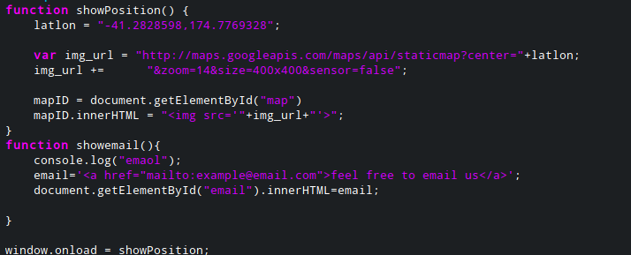





Id map is for where the map centered on wellington goes

Id email is a button that is replaced by the email link for the website

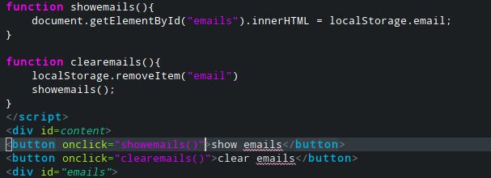

This is the *collected_data.html* page this just has a button that gets the email data and displays it to the screen.

And a button to clear the local storage item email

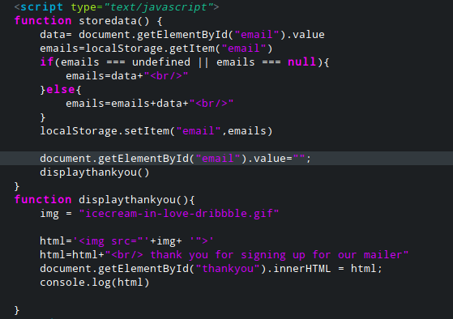

This is off of mailer.html there is store data that takes the data from the text box that is “email”

And put that data into localStorage.email adding it to the list separated by <br/>

